East Lake Wrestling Sponsorships
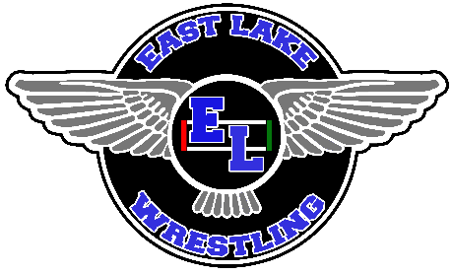
Home Event Programs
Programs will be distributed at our East Lake Tournament and home dual meets. This a great way to advertise local businesses or even give your son or daughter a shout out for his or her hard work! If you are not interested in an ad, donations are graciously accepted and will go directly towards wrestling equipment, entry fees, and supplies.
- ½ page Ad in Program - $50.00
- Full page Ad in Program - $100.00
Gym Banners
Gym Banners stay up for the entire school year. They are visible during Wrestling, Boys Basketball, Girls Basketball, and Volleyball games. In addition to your gym space banner, you will also get an ad in the wrestling program.
- Large Banner (Approx. 3’ x 5’): $500
- Small Banner (Approx. 2’ x 3’): $300
Deadline: November 30th
Sponsorship checks made payable to EAST LAKE WRESTLING BOOSTERS
Contact Name _________________________________________________________________________
Business Name ________________________________________________________________________
Address ______________________________________________________________________________
Email ________________________________________________________________________________
Contribution Amount ___________________________________________________________________
Ad Size (Circle One)
½ Page Ad
Full Page Ad
Small Gym Banner
Large Gym Banner
Donation
*Please send all information you would like the ad to specifically say along with all digital artwork to Coach Golombek at golombekr@pcsb.org

